37.55: a) 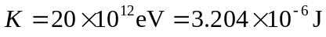
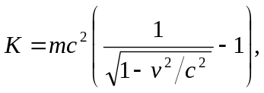 so 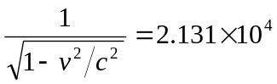
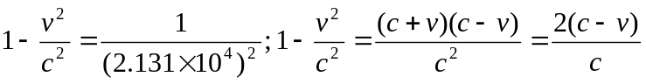 since 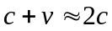
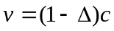 so 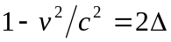 and 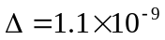
b) 